Health Announcements K-5 2019
April – Dental Health
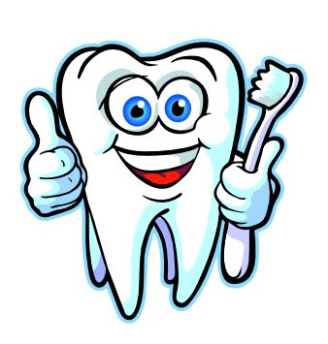
- Take care of your teeth. Make sure you brush and floss your teeth twice a day, eat lots of healthy foods and visit a dentist at least once a year.
- Every night, brush your teeth, read a favorite book (or two!) and go to bed at the same time each night. To help you remember, think of the 3 B’s - Brush, Book, Bed!

- Did you know an elephant's tooth can weigh up to 3 kilograms? That's heavier than a big jug of milk! If your teeth were that big, it would take a lot of toothpaste to brush them! Make sure you brush your teeth at least twice a day, in the morning and before bed.

- Interesting fact - even though snails are very small, they have thousands of tiny teeth all lined up in rows. That’s a lot of teeth take care of! Be thankful you are not a snail and that it is easy to brush your teeth twice a day.

- This month we remember how it is important to take care of our teeth and visit a dentist at least once a year. Q: What did the vampire say after the dentist finished checking his teeth? A: Fang you very much! Remember to see your dentist at least once a year.

